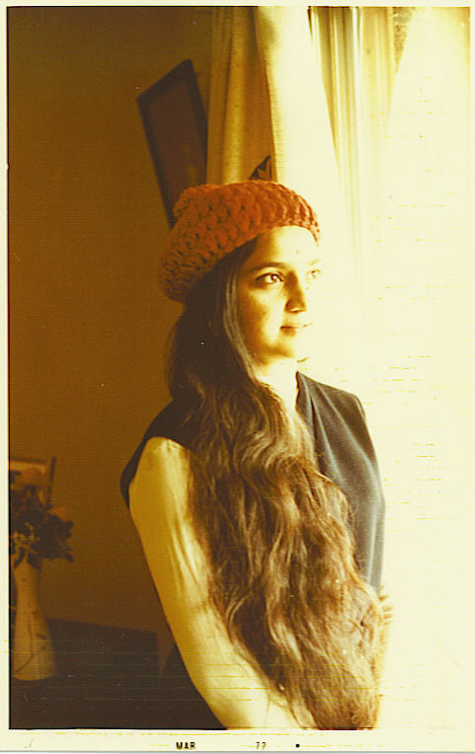
Smile in Tears
આંસુમાં સ્મિત
Author: Saryu Parikh
લેખિકા: સરયૂ પરીખ
True stories in prose and verse in English & Gujarati.
POEMS - કાવ્યો
A Moment
My wings may swing in worthless flight,
My eyes visualize this useless blight,
A moment of comment, a shared insight,
A gleam of a thousand delights....
એક ક્ષણ
અંતર પારેવાની પાંખો વીંઝાય,
પવન કેરા પાલવમાં પંખી ઘૂમરાય.
ઉગમ ટકોરો ને દ્વાર ખૂલી જાય,
રે શત શત બુંદોની બોછાર.
When you work, you are a flute through whose heart
the whispering of the hours turns to music.
. . . And what is to work with love?
It is to weave the cloth threads drawn from your heart,
even as if your beloved were to wear that cloth . . . __Khalil Gibran, The Prophet.
Book-1 “નીતરતી સાંજ Essence of Eve,” poems and stories,
author Saryu Parikh - paintings by Dilip Parikh. 2011
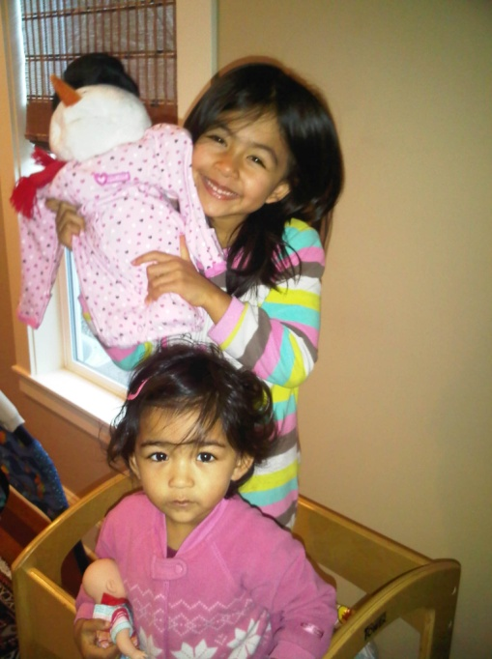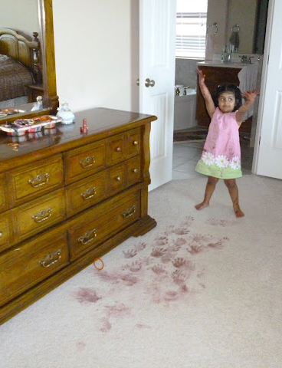
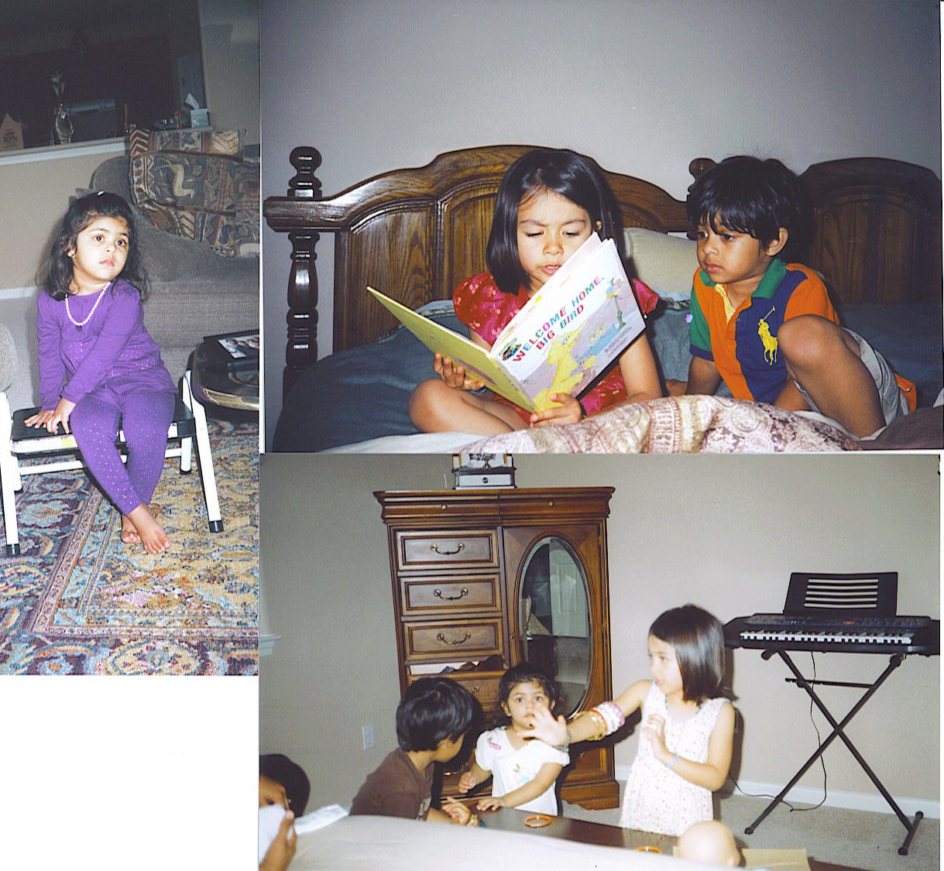 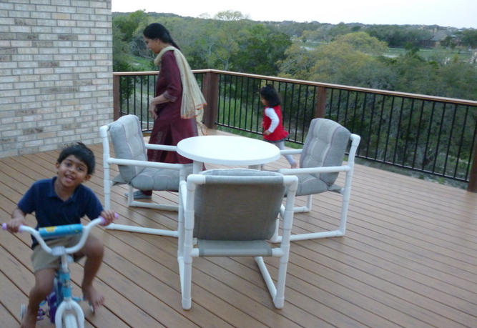 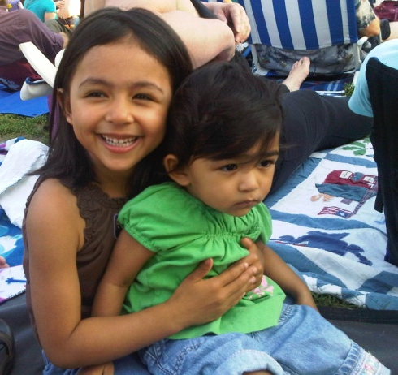
Sufiya Kethan Ava Sonia
Every person’s life is a story in itself, especially when I started observing every individual as a character and the invisible Almighty as a director. My stories and poems are the result of the tender touching of human hearts. A cry for help should not go unanswered.
National Domestic Violence Hotline. www.NDVH.org. 800-799-7233
It is best to find a local Family Violence Service provider.
I was born and raised in Bhavnagar, Gujarat State, India, surrounded by poets in the family. Married to Dilip, we have made our home in the USA. I feel blessed with two children and four grandchildren. saryuparikh@yahoo.com Phone# 512-712-5170 Austin, Texas.
“A Special Volunteer... .Saryu Parikh, a dedicated volunteeer. It is rare that you come across someone whose commitment
to volunteering means she is available to people all hours of the day. Saryu is such a person.
Her name can be found on a number of local nonprofits, including the Literacy Council Of Fort Bend County, Women’s Center, and Asians Against Domesic Abuse just to name a few.
She has been a dedicated tutor, a helper to battered women and much more. . . . Currently, she is a volunteer for the nonprofit American Gateways in Austin. . . . A woman of multifaceted talents.
Volunteer-Fort Bend Focus CareS.”
Saryu’s Book-1 in 2011: “નીતરતી સાંજ..Essence Of Eve” of Poems, Experiences,
in Gujarati & English with DILIP’S PAINTINGS. www.saryu.wordpress.com.
Book-2 “Smile in Tears આંસુમાં સ્મિત.” $20. Books available. HDKP@yahoo.com

