A brief note on paintings #1, #2, #3:

E=MC² paintings (#1, #2, #3) have two aspects: Physics and Spiritual.
Physics aspect: Matter and Energy are two different states
of the same thing (Einstein: E = MC²).
“There was a time called the big bang when the universe was infinitesimally
small and dense. God created the universe at
the big bang.” (Stephen Hawkins).
The ‘black circle’ in the center represents a ‘black hole’
— a source of the energy, which manifested as the visible universe.
Everything is nothing but the Energy.
Spiritual aspect: The Unmanifested, the Infinite, the Changeless Spirit is called Brahman: the one Absolute. This is described as Aum-Tat-Sat.
Aum is the creative vibration that upholds the worlds through Prakriti, mother nature. All created things originate in the cosmic energy of Aum —the universal energy manifested as matter. The limitless Brahman remains unchanged even after the infinite universe comes out of it.
The experience of duality is an illusion (unreal).
Everything is nothing but the limitless, infinite Brahman.
The painting (#1) shows “Maya” as a power of creation. The other paintings have two faces (Purush and Prakriti, Brahman and Maya) merged in one, representing absolute and manifested energy. It is Brahman who projects the universe through the power of His Maya.
The creator and the creation are not separate, but one.

A brief note on paintings #4, #5: (Satyam, Shivam, Sundram)
When a dancer (or a musician) becomes one with the dance (or music),
there is no interference of thoughts. The movement of moment
(which is time) stops, and one may experience inner Bliss.
This is a state of meditation.When the mind is totally free of its content
(a state of pure silence) then “Satyam” (truth) is experienced.
“Shivam” is “Satyam” in action; one lives from moment to moment.
When every action is “Shivam” then this totality flowers as beauty,
which is “Sundram.”

----------
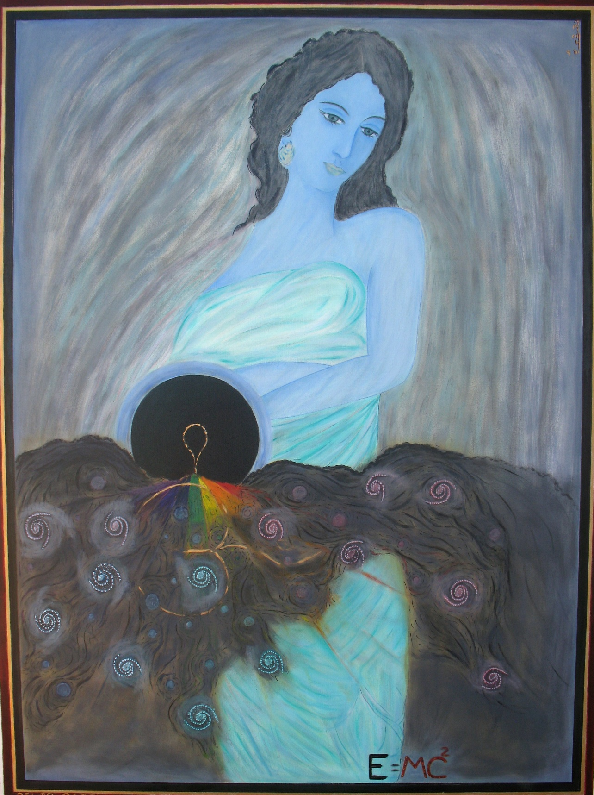
#1. CREATION

Details of -#2

# 2 BRAHMAN-MAYA

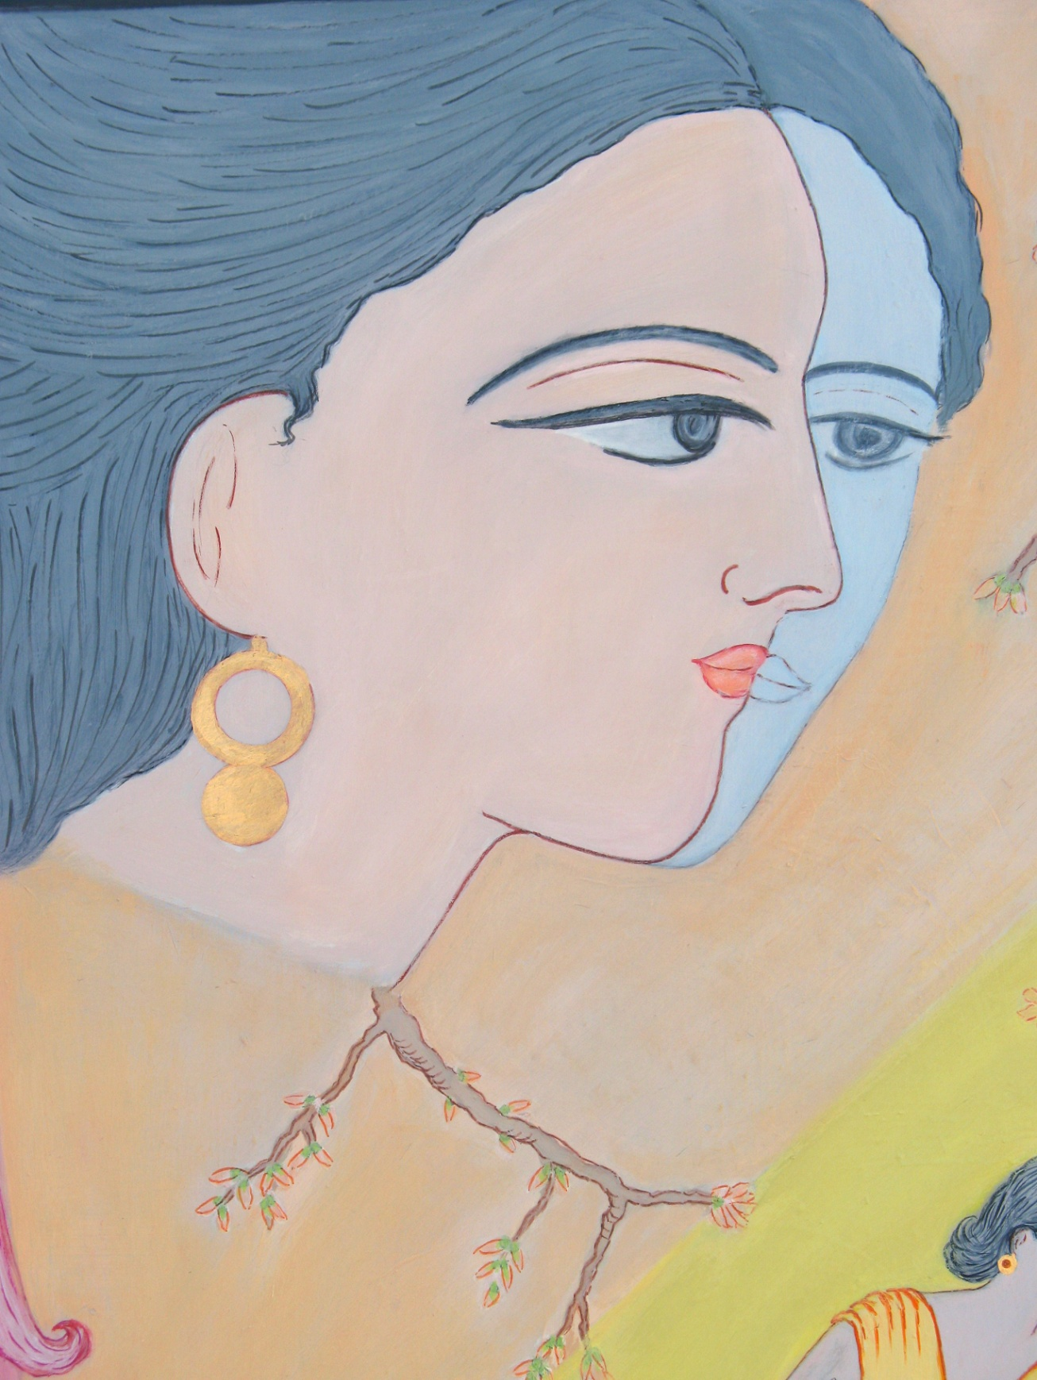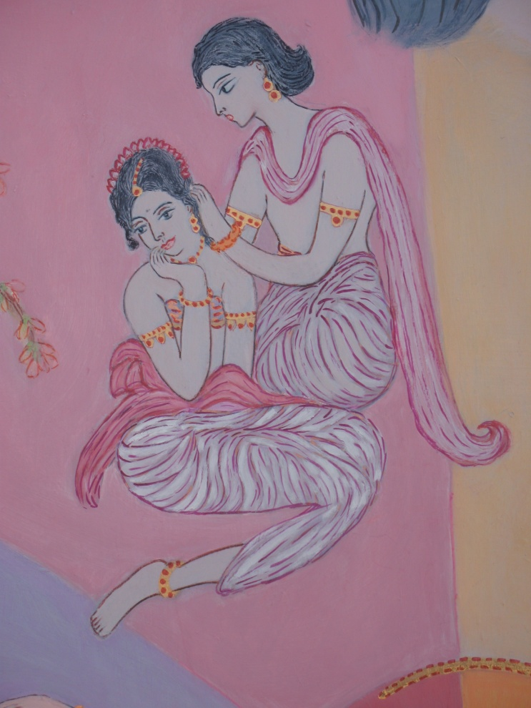

Details of #3

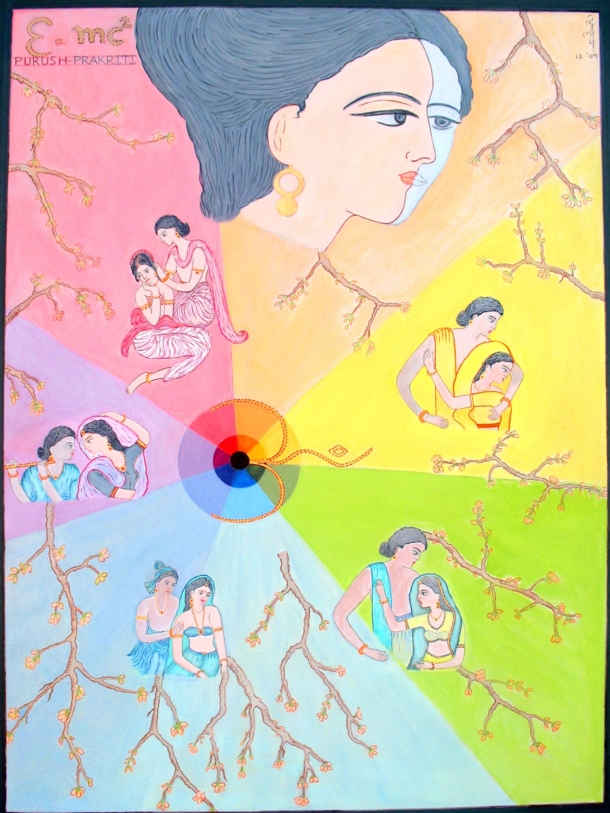
#3 PURUSH AND PRAKRITI

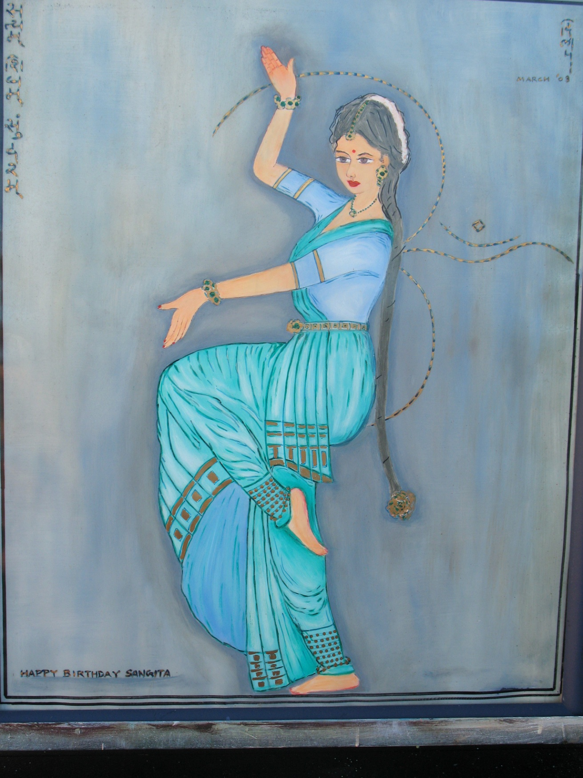
SATYAM SHIVAM SUNDARAM. #4 DANCE
કાવ્યોમાં ભાવભીની લાગણીનુ નર્તન, સત્ય શિવમ ચેતનાનુ નૃત્યોમાં દર્શન.

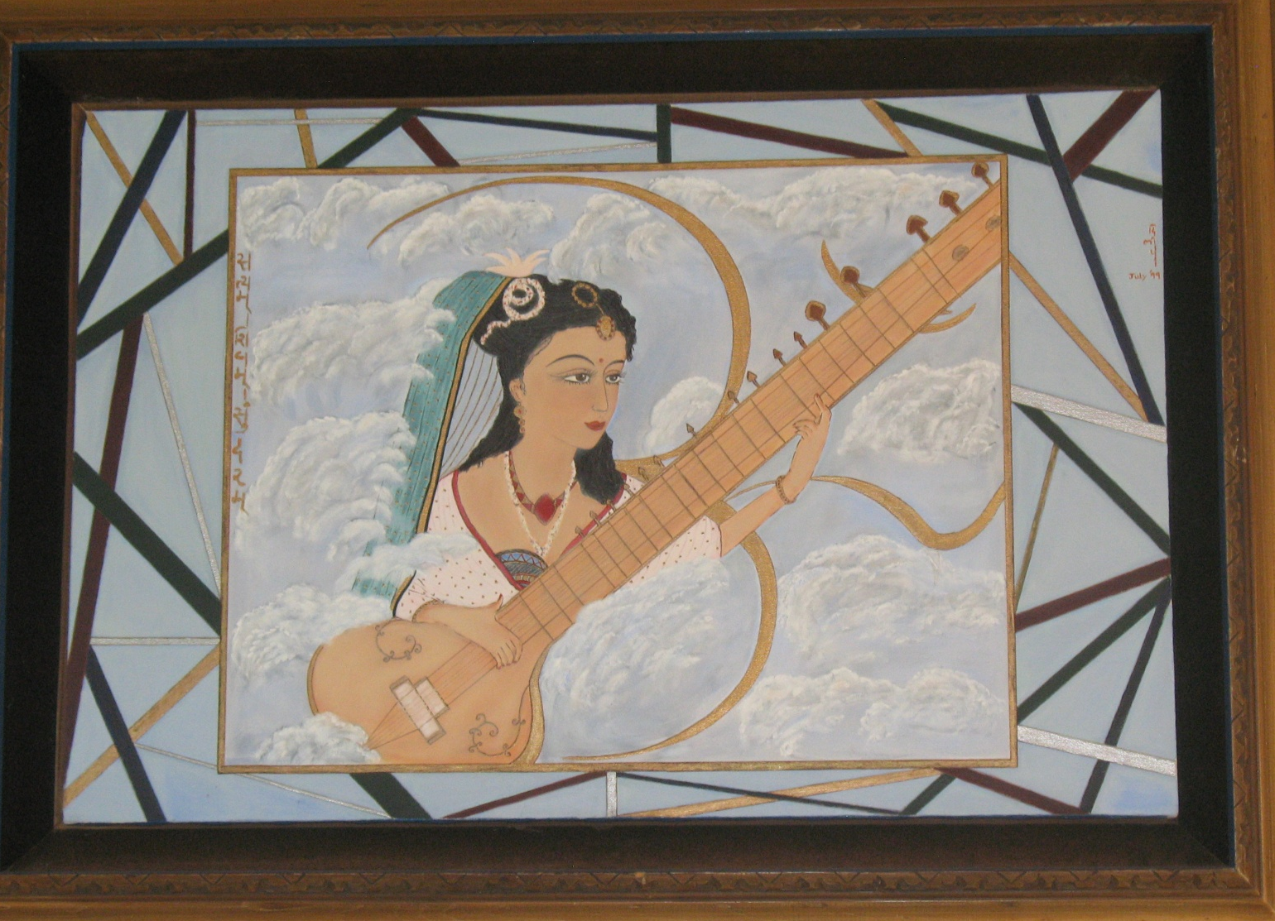
SATYAM SHIVAM SUNDARAM #5 MUSIC
સાધકનુ દિવ્ય જીવન સાધનાને અર્પણ
ફલશ્રૂતિ સુખ શાંતિ પ્રણવને સમર્પણ

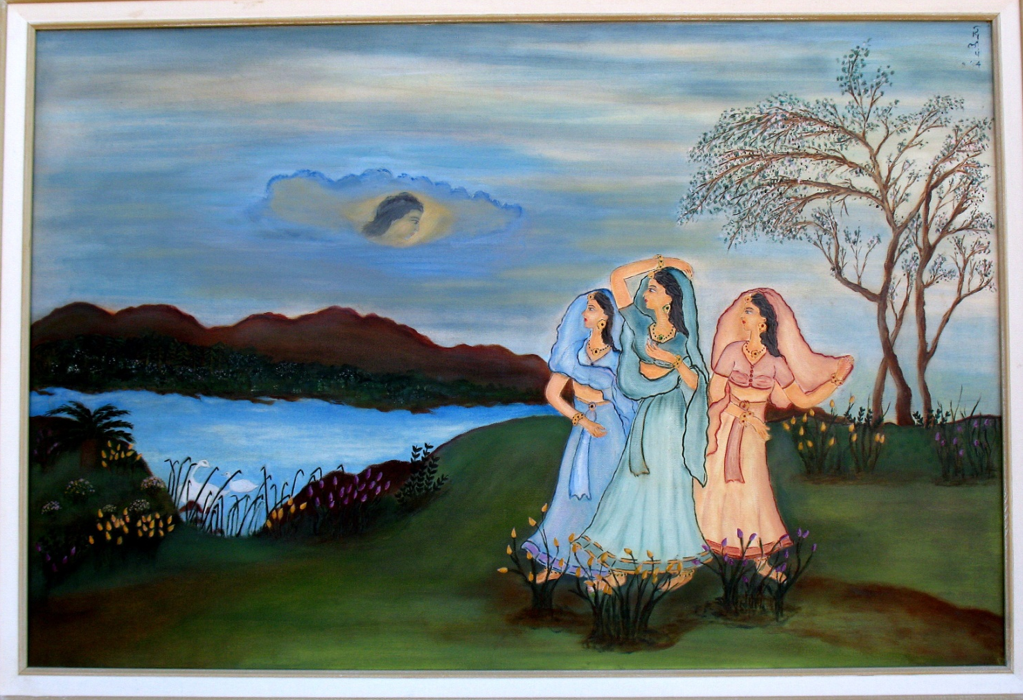
#6 મેઘદૂત
સાંવરિયા ના આવીયા, પરવશ હશે વિદેશ
વિહ્વળ વ્યાકુળ સાહેલી, સૂણ મેઘદૂત સંદેશ

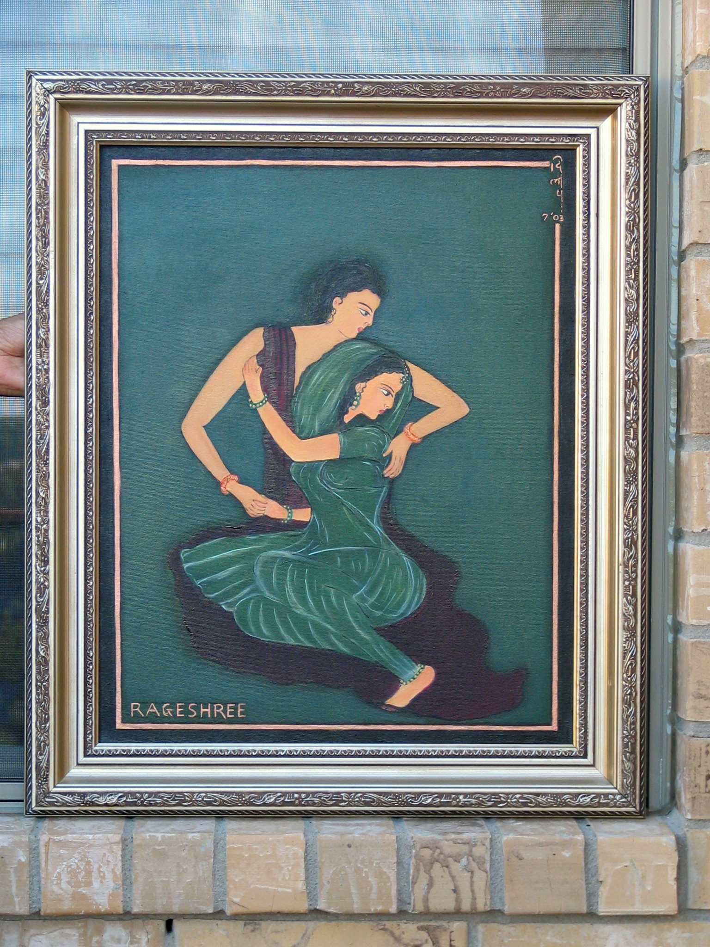
# 7 RAGESHREE
મંજુલ એ પ્રેમરાગ કેટલીયે રાત , રસિલી લય રચના અનેક વિધ વાત

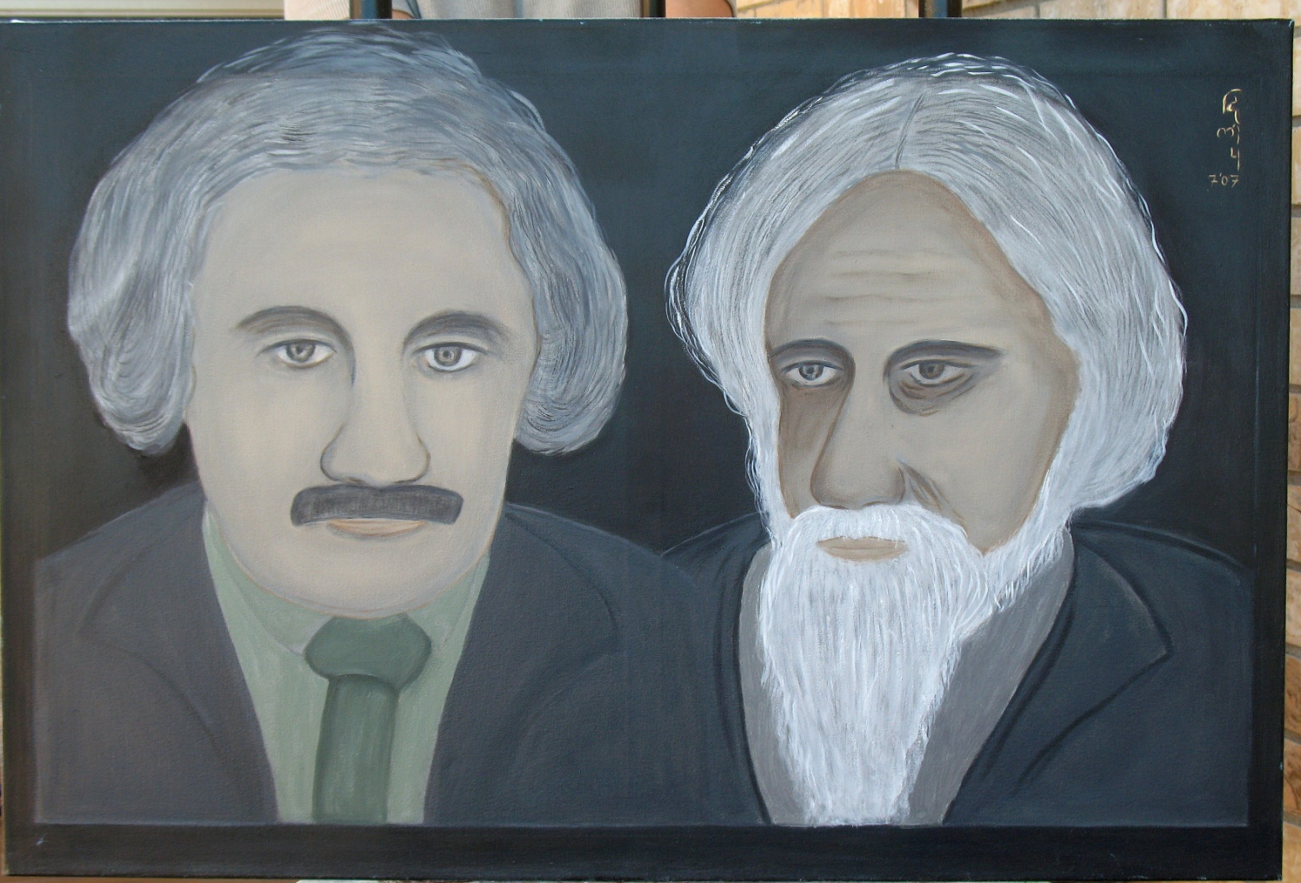
#8 Einstein and Tagore

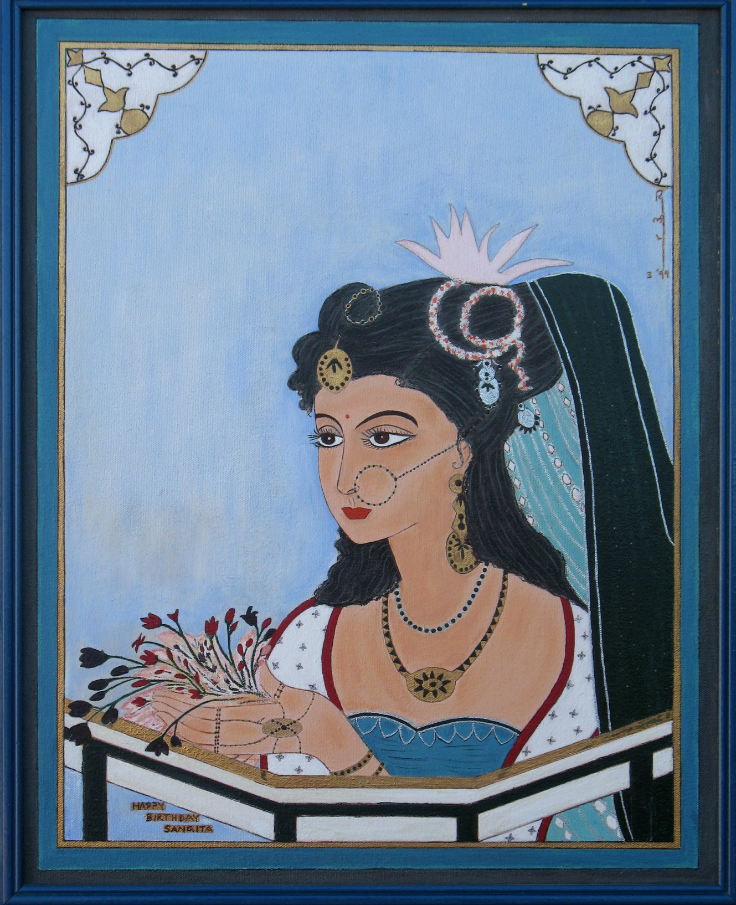
# 9 DEVOTION

